**Programming ESP32 with Arduino IDE:**

**STEP 1:**Connect your ESP32 board to your computer through the micro-USB cable. Make sure the red LED goes high on the module to ensure power supply.

**STEP 2:**  Start the Arduino IDE and navigate to *Tools -> Boards and select ESP32Dev* board as shown below

[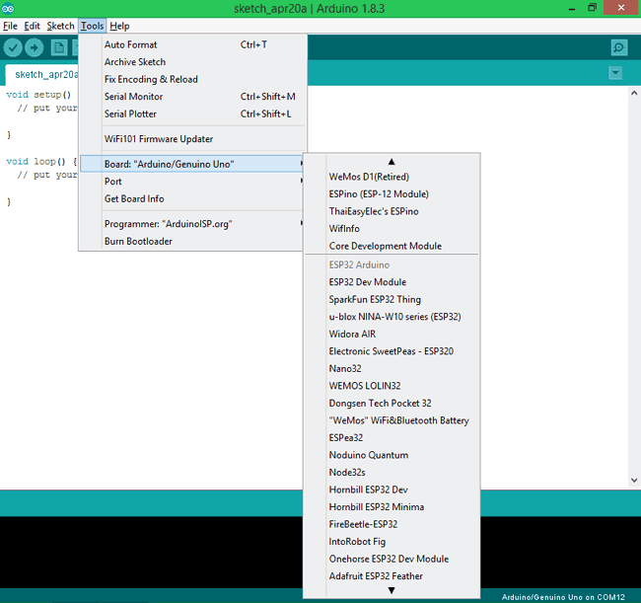](https://circuitdigest.com/fullimage?i=inlineimages/u/Select-ESP32Dev-from-tools.png)

**STEP 3:** Open device manager and check to which com port your ESP32 is connected to. Mine is connected to COM 8 as shown below

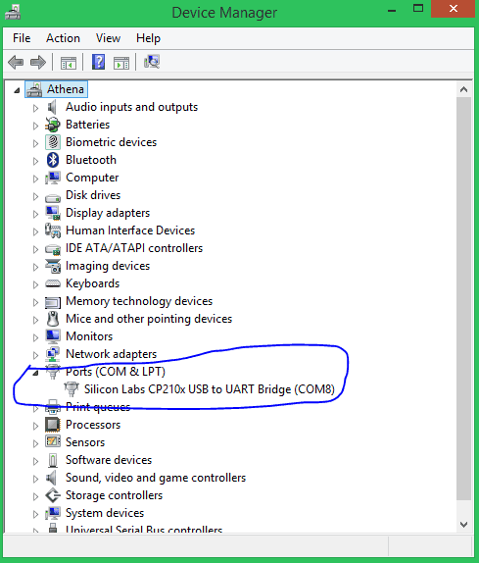

**STEP 4:** Go back to Arduino IDE and under *Tools -> Port select* the Port to which your ESP is connected to. Once selected you should see something like this on the bottom left corner of the IDE.

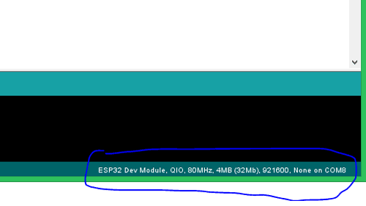

**STEP 5:** Let’s upload the Blink Program, to check if we are able to program our ESP32 module. This program should blink the LED at an interval of 1 second.

**int LED_BUILTIN = 2;**

**void setup() {**

**pinMode (LED_BUILTIN, OUTPUT);**

**}**

**void loop() {**

**digitalWrite(LED_BUILTIN, HIGH);**

**delay(1000);**

**digitalWrite(LED_BUILTIN, LOW);**

**delay(1000);**

**}**

The program is very similar to the Arduino blink code hence I am not explain them in detail. But one change is that, here in ESP32 the LED on board is connected to pin number 2, while for Arduino it will be connected to pin number 13.

**STEP 6:** To upload the code, just click on upload and you should see the Arduino console displaying the following if everything works as expected.

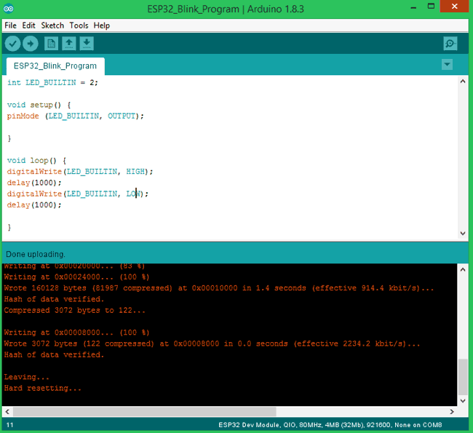

**Note**: For some modules, you might have to hold the Boot button during uploading to avoid error.

That is it we have successfully uploaded out first code to our ESP32 board. **My module with its LED blinking is shown below**

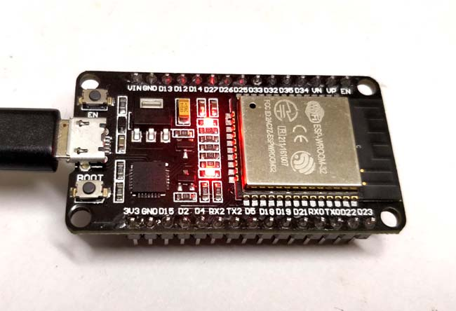

This is how **Programming ESP32 using Arduino IDE** can be implemented. You can go ahead and try the other example programs which are available at *File -> Example  -> ESP32* to work with other functionalities of the ESP32. If you have had any problem in getting this work, feel free to post the query on the comment sections below. You can also use the Forum for getting technical help.

**Code**

int LED_BUILTIN = 2;

void setup() {

pinMode (LED_BUILTIN, OUTPUT);

}

void loop() {

digitalWrite(LED_BUILTIN, HIGH);

delay(1000);

digitalWrite(LED_BUILTIN, LOW);

delay(1000);

}